In actual business scenarios, it is often necessary to perform IO operations or connect to databases within loops. Due to unstable network conditions or large data volumes, this can lead to Out Of Memory (OOM) errors. In such cases, it is necessary to ensure that the process can complete smoothly while also reporting any exceptions that occur.
This simulates an exception collection process: the Python node is artificially triggered to generate exceptions, while the Table Creator node configures a numeric column named “error”. This “error” column is then converted into a variable with an initial value of 0, serving as a global variable for the entire workflow. This setup allows for easy determination of whether any exceptions occurred after the Loop End node, facilitating conditional branching in subsequent steps (such as triggering email notifications or other operations).

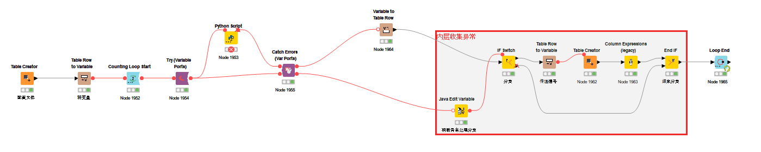
Java Edit Variable configure:
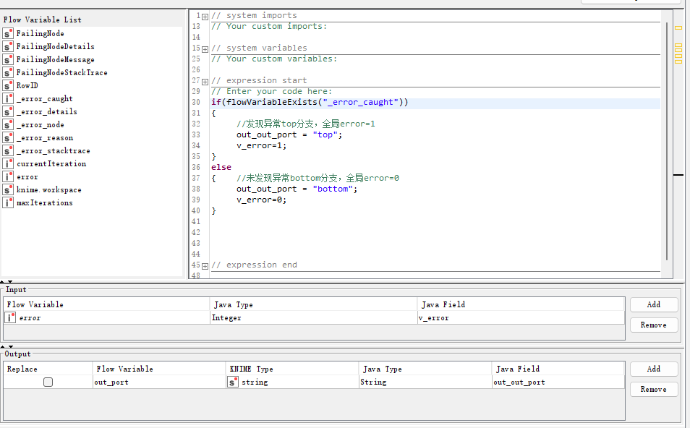
The issue is that the Loop End node shows the error variable value remains 0.
