Read the data into 3 columns
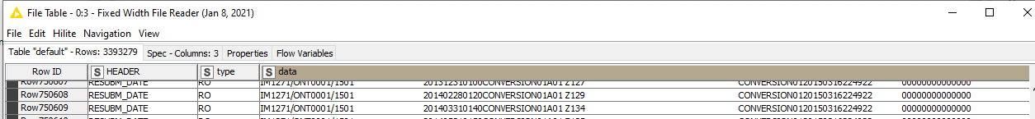

Process the “data” column using “Cell Splitter By Position”
