# Batch command to run KNIME workflow:

Hello KNIME community,

I am not sure how to address the following issue I am experiencing.

I have the following workflow that uses the Custom Excel Writer at the end to create a file that automatically appends the date/time to the file name each time this workflow is run:

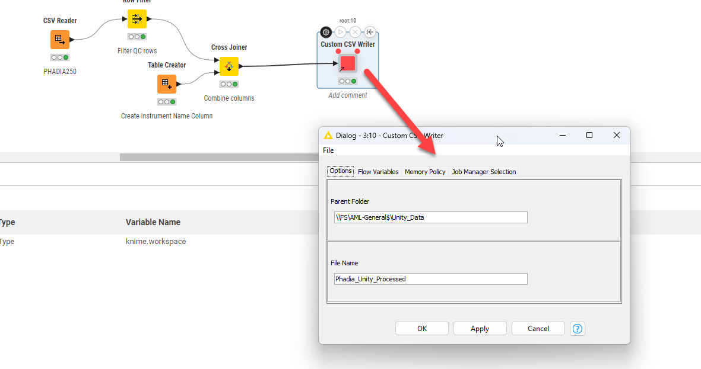

The file that is created when this entire workflow is executed is as per example below:

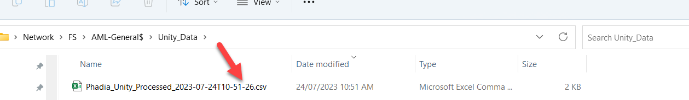

I have created a batch file that I want to run daily at a specific time with the following parameters:

"C:\Program Files\KNIME\knime.exe" --launcher.suppressErrors -nosplash -nosave -reset -application org.knime.product.KNIME_BATCH_APPLICATION -workflowFile="C:/temp/PHADIA_UNITY.knwf"

The issue I am having is that the Custom CSV Writer node is not being triggered. If I manually reset all nodes and execute all nodes, everything works and I have a new file created:

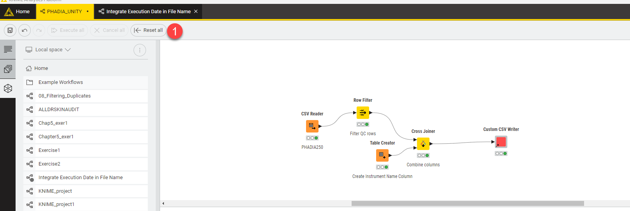

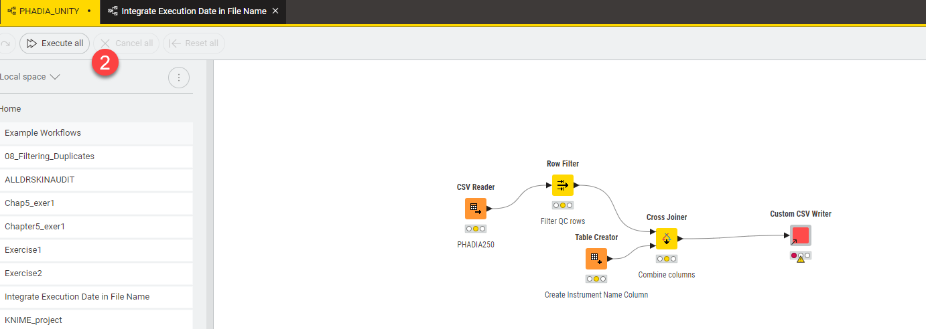

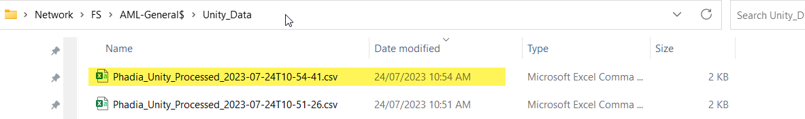

Is there a command that I can specify in my batch file to always run the Reset All (Shift F8) followed by the Execute All (Shift F7) to always ensure the workflow is run correctly and the file names are created with the unique file names? Please note I do not want to overwrite existing files, hence why I am using this custom CSV Writer node.