1. Select py3_knime

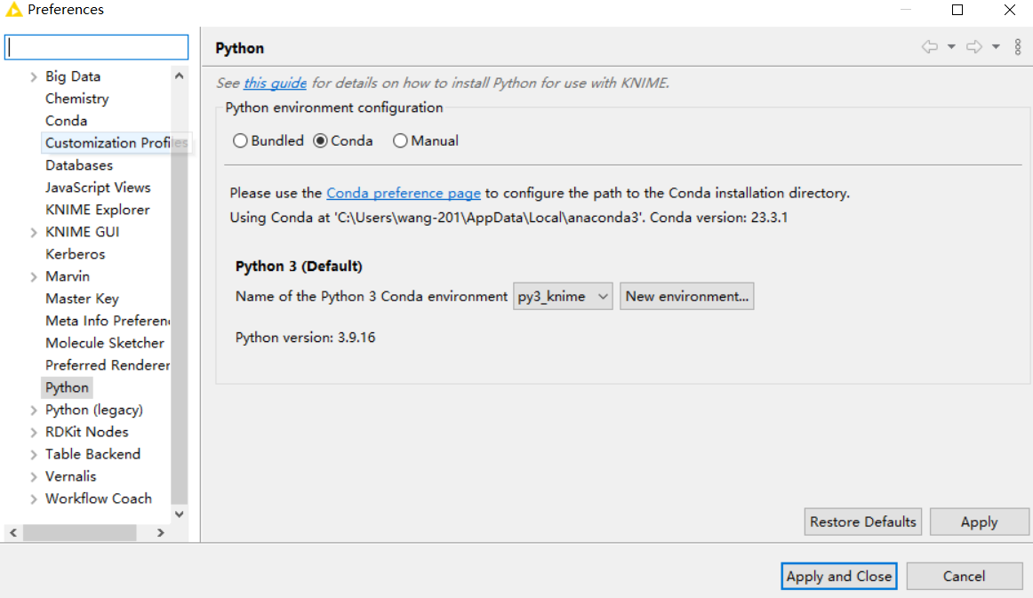

1. Run python codes

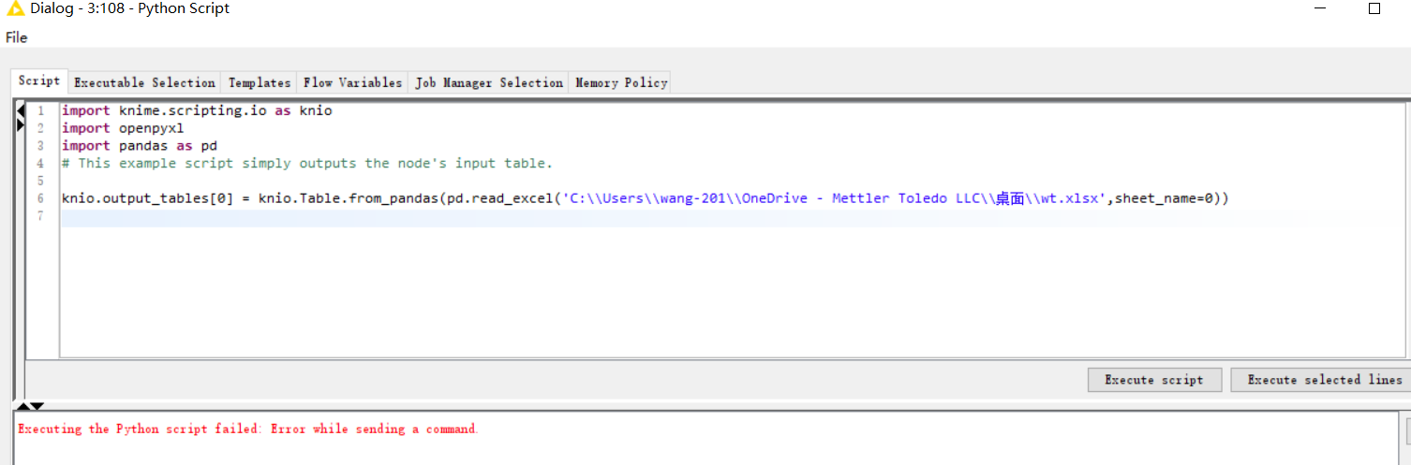

1. Knime log:
2. 2023-05-31 18:57:55,119 : ERROR : KNIME-Worker-59 : : PythonSourceCodePanel : Python Script : 3:108 : Error while sending a command.
3. org.knime.python2.kernel.PythonIOException: Executing the Python script failed: Error while sending a command.
4. at org.knime.python3.scripting.Python3KernelBackend.beautifyPythonTraceback(Python3KernelBackend.java:702)
5. at org.knime.python3.scripting.Python3KernelBackend.beautifyPythonTraceback(Python3KernelBackend.java:677)
6. at org.knime.python3.scripting.Python3KernelBackend.executeAndCheckOutputs(Python3KernelBackend.java:608)
7. at org.knime.python2.kernel.PythonKernel.executeAndCheckOutputs(PythonKernel.java:486)
8. at org.knime.python2.kernel.PythonKernelManager.lambda$1(PythonKernelManager.java:208)
9. at org.knime.python2.kernel.PythonKernelManager$3.run(PythonKernelManager.java:225)
10. at org.knime.core.util.ThreadUtils$RunnableWithContextImpl.runWithContext(ThreadUtils.java:367)
11. at org.knime.core.util.ThreadUtils$RunnableWithContext.run(ThreadUtils.java:221)
12. at java.base/java.util.concurrent.Executors$RunnableAdapter.call(Unknown Source)
13. at java.base/java.util.concurrent.FutureTask.run(Unknown Source)
14. at org.knime.core.util.ThreadPool$MyFuture.run(ThreadPool.java:123)
15. at org.knime.core.util.ThreadPool$Worker.run(ThreadPool.java:246)
16. Caused by: py4j.Py4JException: Error while sending a command.
17. at py4j.CallbackClient.sendCommand(CallbackClient.java:397)
18. at py4j.CallbackClient.sendCommand(CallbackClient.java:356)
19. at py4j.reflection.PythonProxyHandler.invoke(PythonProxyHandler.java:106)
20. at jdk.proxy16/jdk.proxy16.$Proxy42.executeOnMainThread(Unknown Source)
21. at org.knime.python3.scripting.Python3KernelBackend.lambda$13(Python3KernelBackend.java:608)
22. at org.knime.python3.scripting.Python3KernelBackend.beautifyPythonTraceback(Python3KernelBackend.java:675)
23. ... 10 more
24. Caused by: py4j.Py4JNetworkException: Error while sending a command: c
25. t
26. executeOnMainThread
27. simport knime.scripting.io as knio\nimport openpyxl\nimport pandas as pd\n# This example script simply outputs the node's input table.\n\nknio.output_tables[0] = knio.Table.from_pandas(pd.read_excel('C:\\\\Users\\\\wang-201\\\\OneDrive - Mettler Toledo LLC\\\\桌面\\\\wt.xlsx',sheet_name=0))\n
28. btrue
29. e
30. at py4j.ClientServerConnection.sendCommand(ClientServerConnection.java:253)
31. at py4j.CallbackClient.sendCommand(CallbackClient.java:384)
32. ... 15 more
33. Caused by: java.net.SocketException: Connection reset
34. at java.base/sun.nio.ch.NioSocketImpl.implRead(Unknown Source)
35. at java.base/sun.nio.ch.NioSocketImpl.read(Unknown Source)
36. at java.base/sun.nio.ch.NioSocketImpl$1.read(Unknown Source)
37. at java.base/java.net.Socket$SocketInputStream.read(Unknown Source)
38. at java.base/sun.nio.cs.StreamDecoder.readBytes(Unknown Source)
39. at java.base/sun.nio.cs.StreamDecoder.implRead(Unknown Source)
40. at java.base/sun.nio.cs.StreamDecoder.read(Unknown Source)
41. at java.base/java.io.InputStreamReader.read(Unknown Source)
42. at java.base/java.io.BufferedReader.fill(Unknown Source)
43. at java.base/java.io.BufferedReader.readLine(Unknown Source)
44. at java.base/java.io.BufferedReader.readLine(Unknown Source)
45. at py4j.ClientServerConnection.readBlockingResponse(ClientServerConnection.java:313)
46. at py4j.ClientServerConnection.sendCommand(ClientServerConnection.java:229)
47. ... 16 more
48. Caused by: Error while sending a command.