Non-normalized *k*-Means Component Non-normalized Simplified *k*-Means

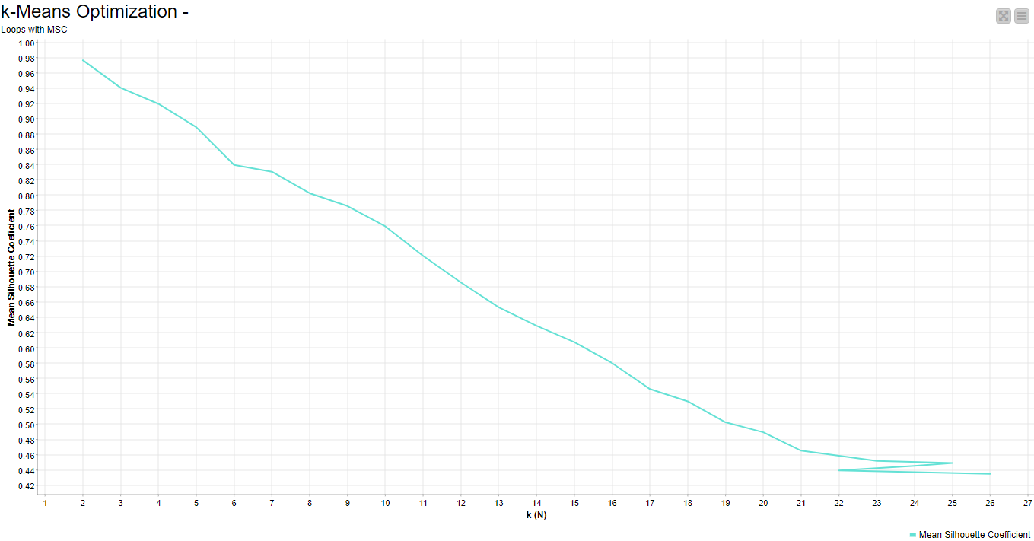 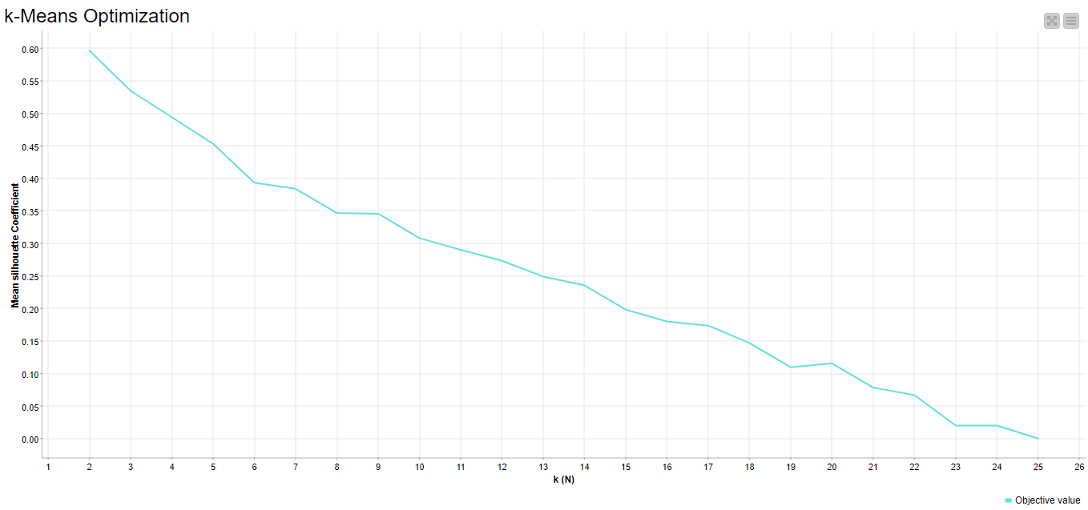

Normalized *k*-Means Component Normalized Simplified *k*-Means

