Hello Denis. Thank you for your quick and prompt reply. My problem at this stage of the workflow design (and my obvious lack of knowledge of KNIME) is restricted as follows:
I am reading the EXCEL file as below:
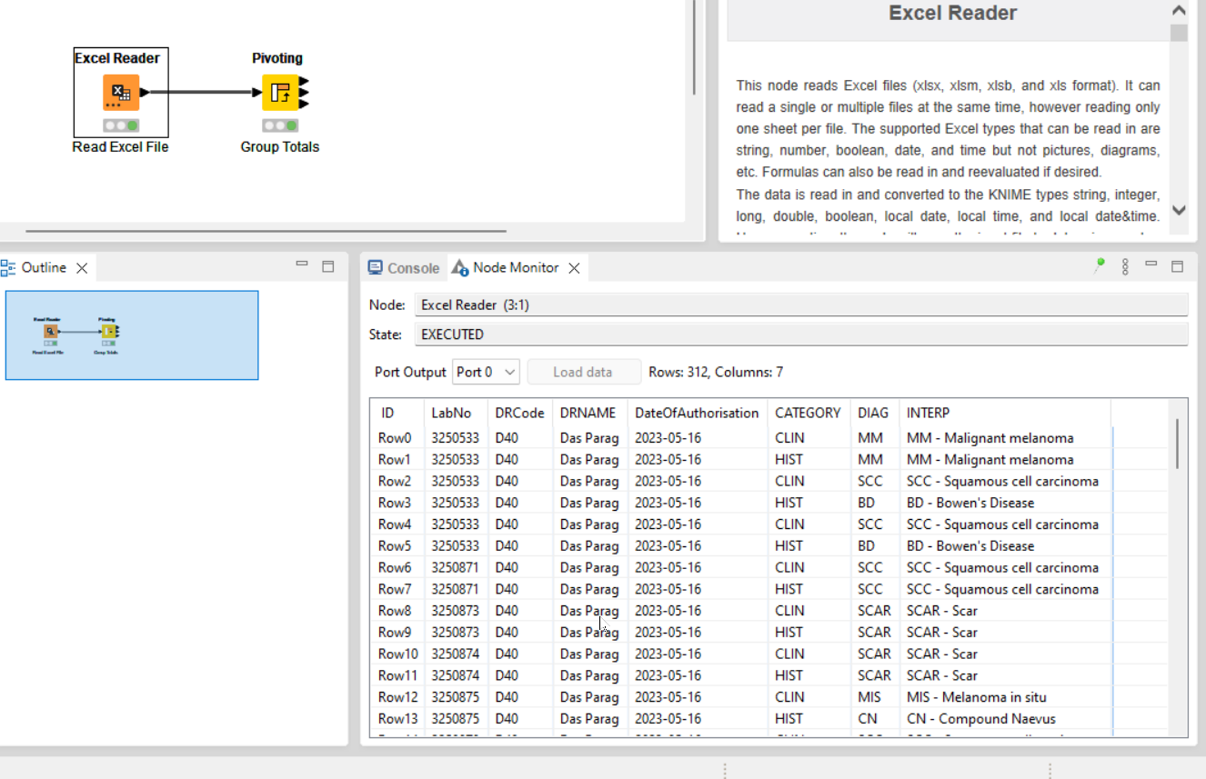
I have added a PIVOT node to display the following:
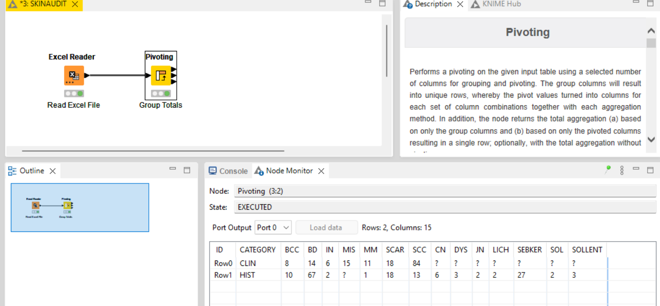
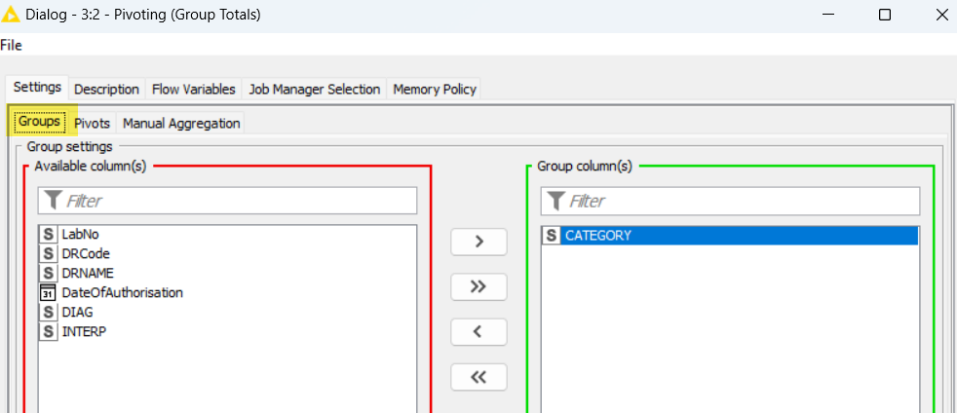
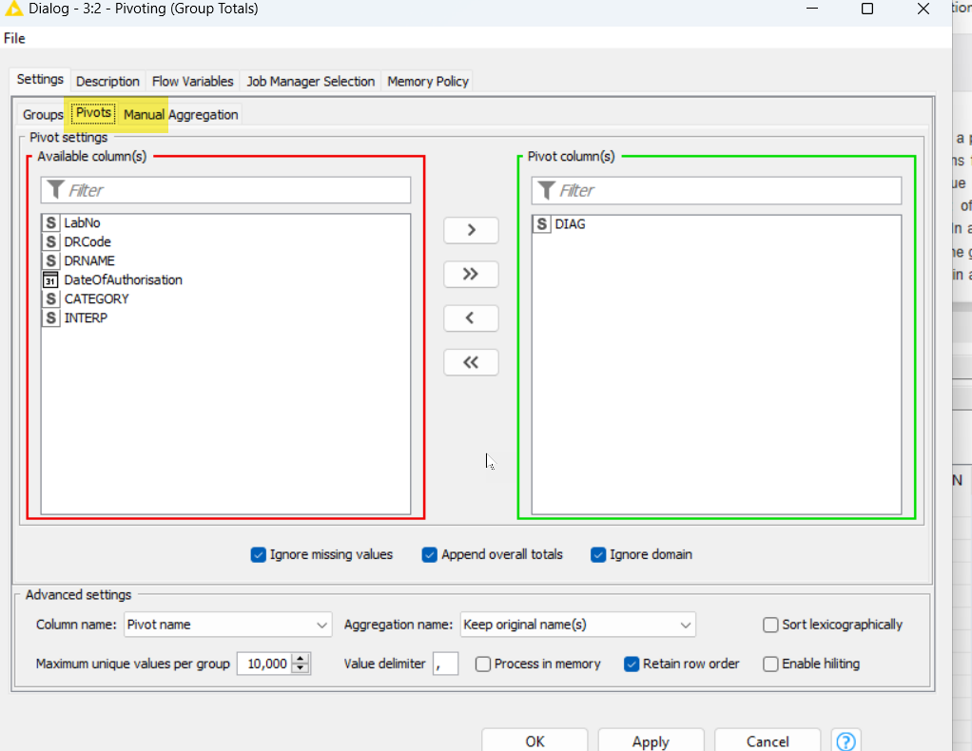
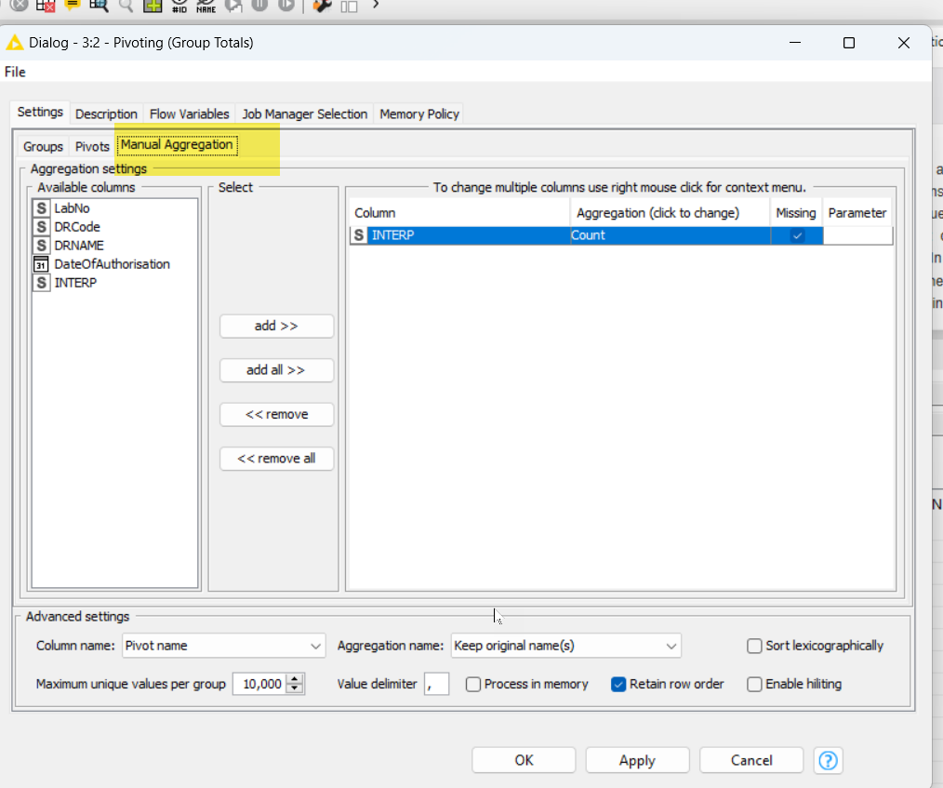
I now wish to calculate the % accuracy for each of the columns, which will be a calculation of Row(0) – CLIN divided by Row(1) HIST * 100
When I am trying to add the Math Formula node to the workflow as per below:
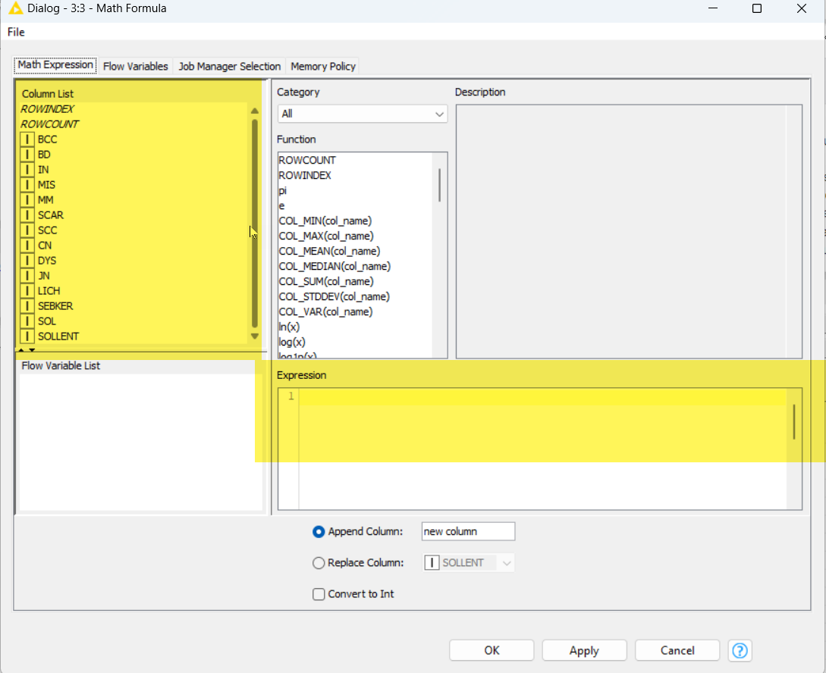
I am not sure what formula syntax? I need to specify to perform my calculation??

