STRING REPLACER
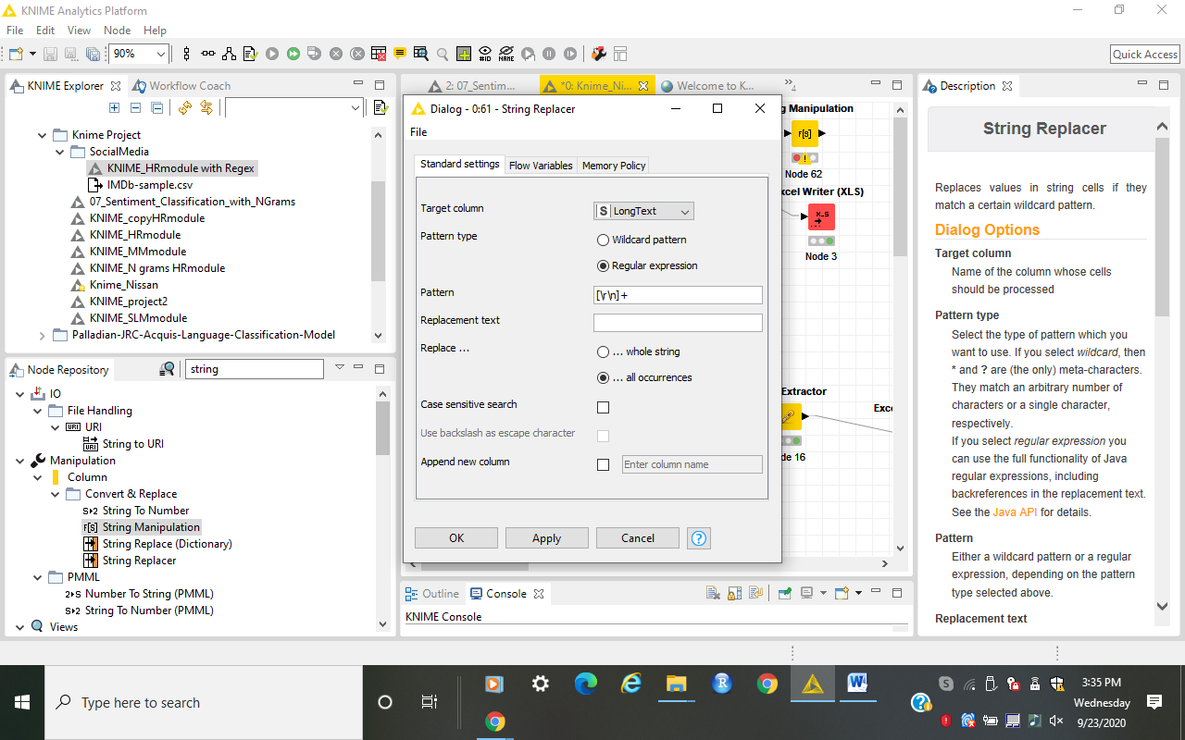

Text starting with TS:______
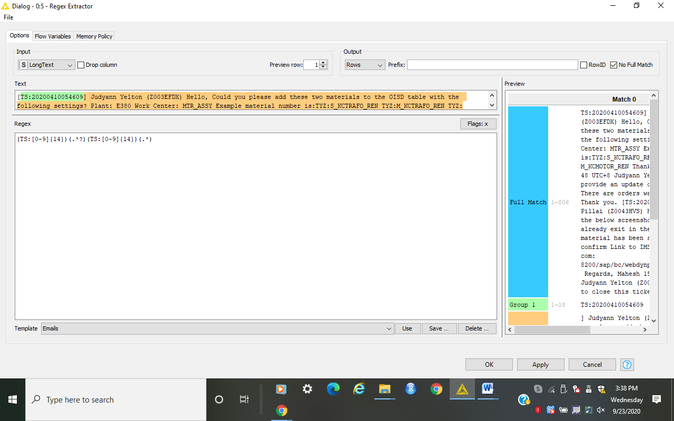
Text between date formats like dd/mm/yyyy or dd.mm.yyyy or dd-mm-yyyy
