- I double click on the file I downloaded.

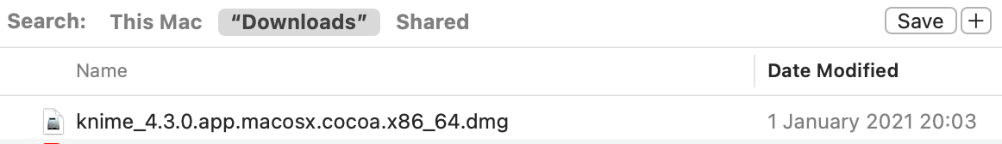

- I moved it to the application folder.

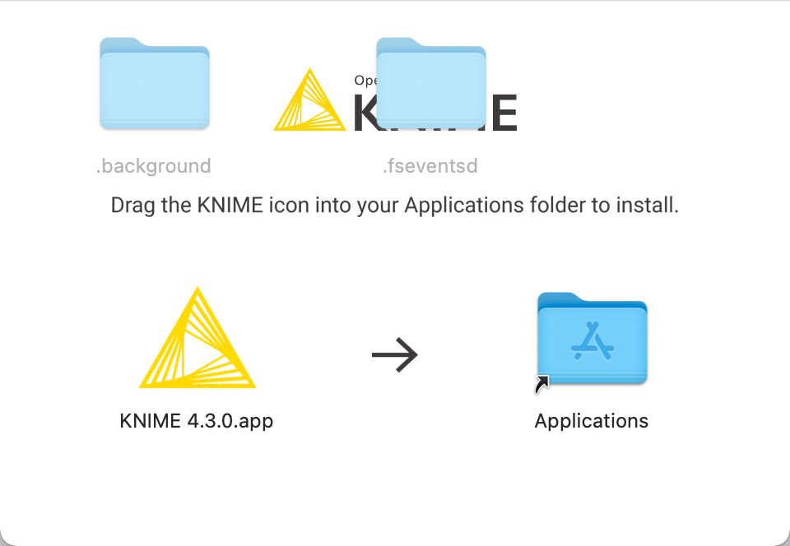

- I run it by double clicking on the application file.

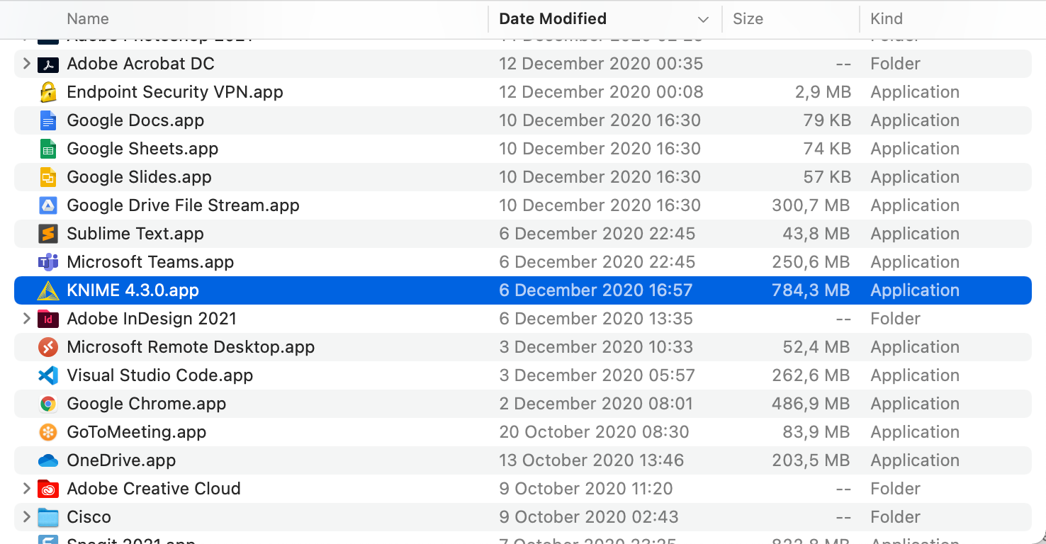

- I clicked the Open button.

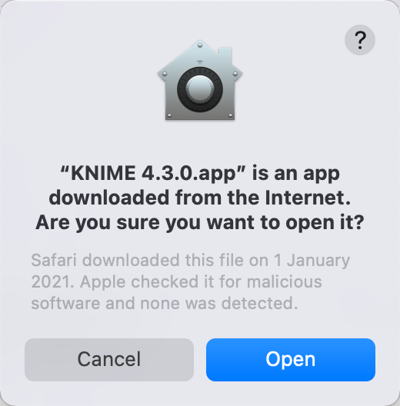

- I created a new workspace.

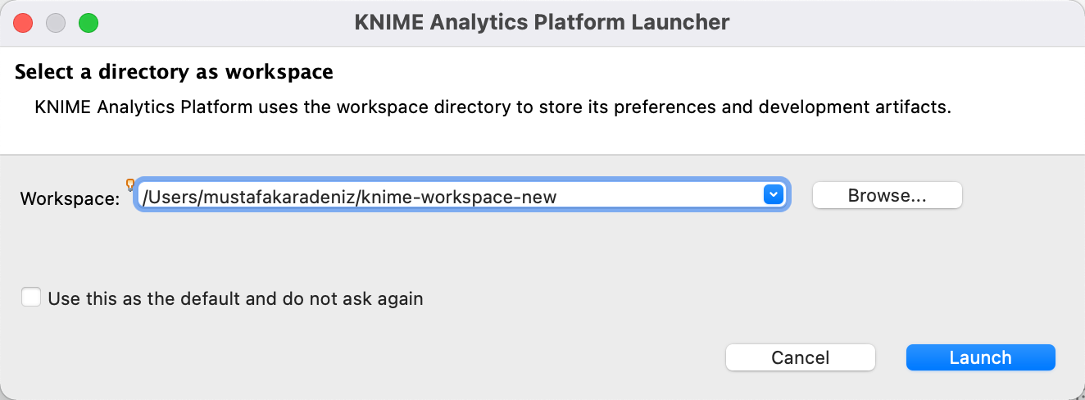

- I clicked yes on bellow dialog.

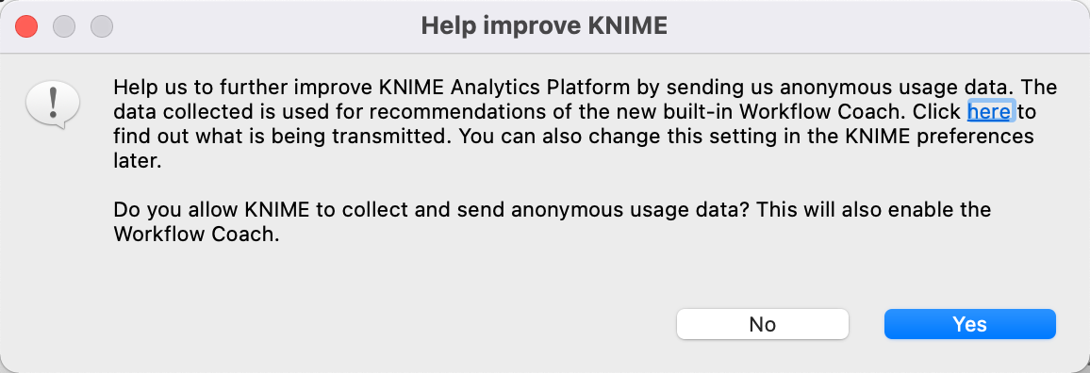

- I clicked “Install Extentions” in File menu.

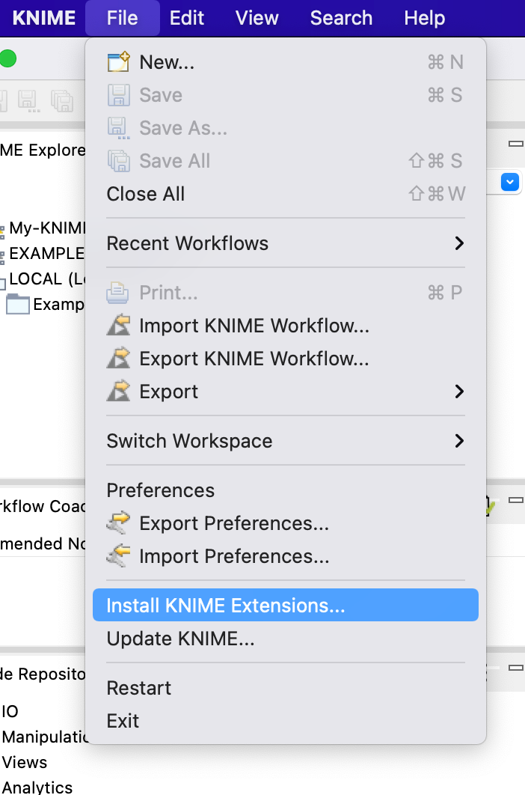

- I checked “KNIME Textprocessing” and clicked Next button.

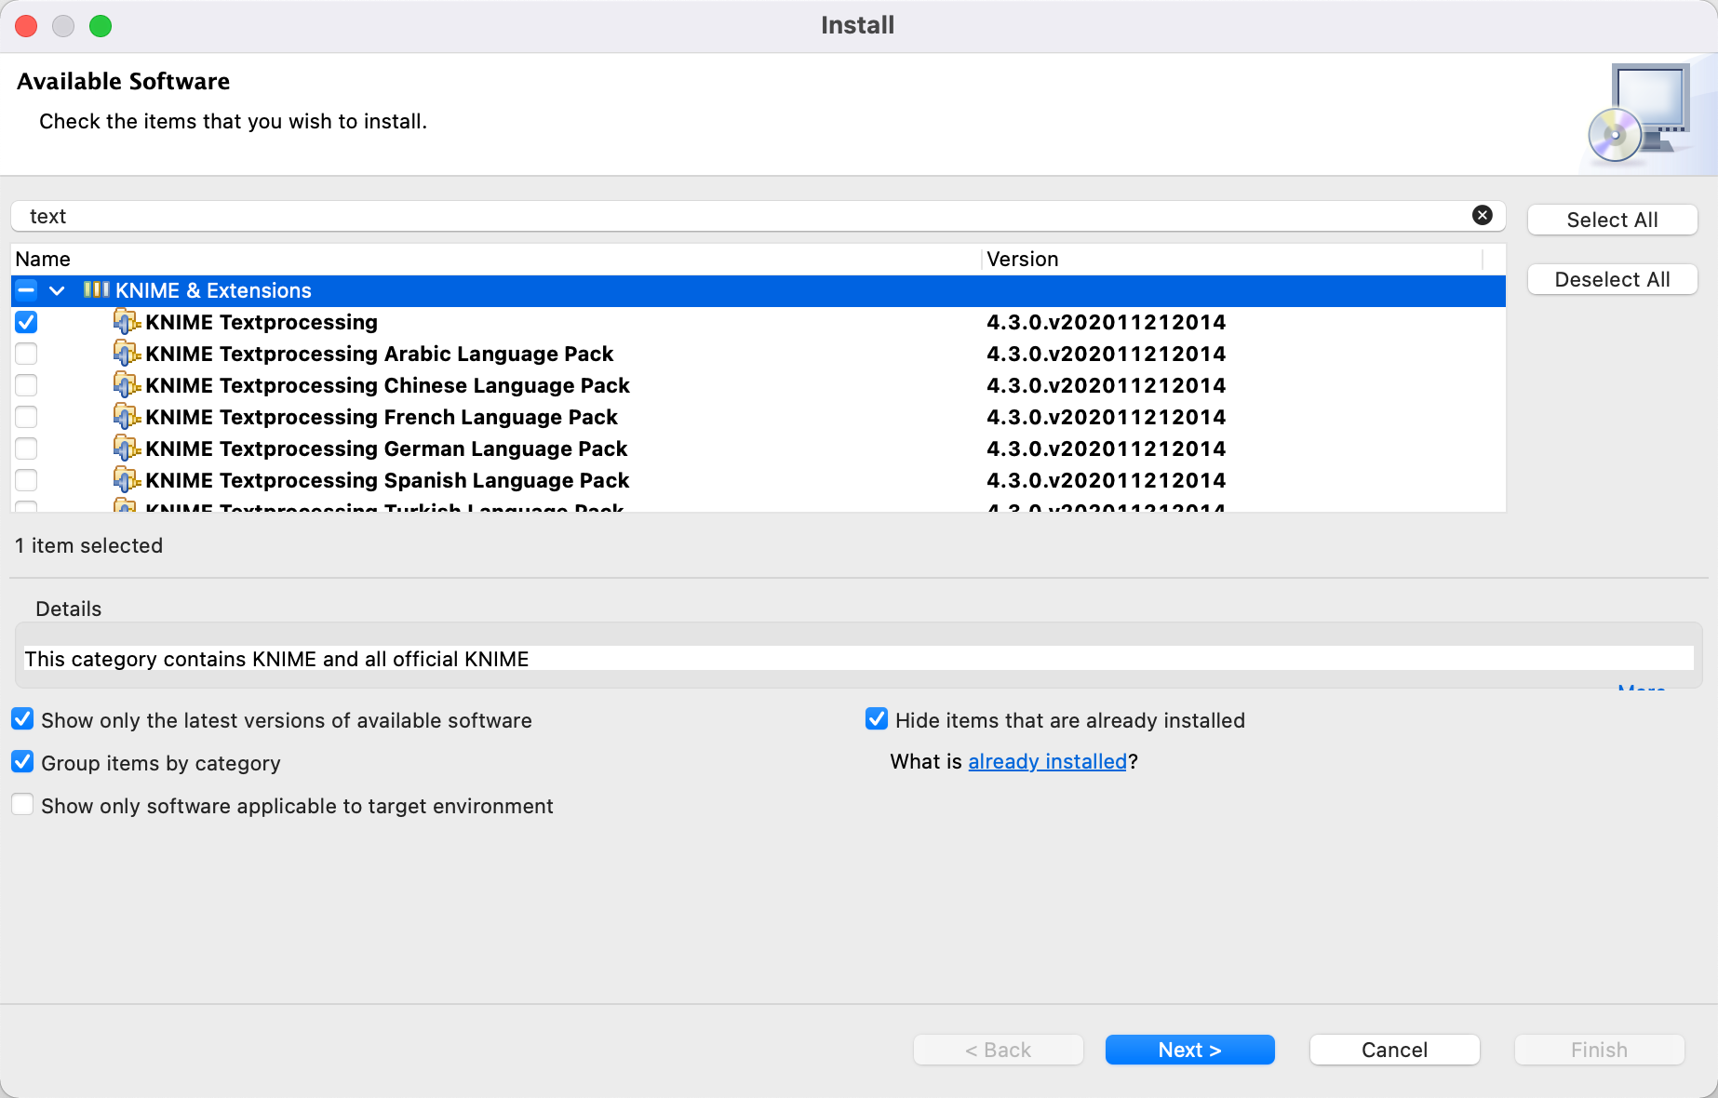

- I clicked Next.

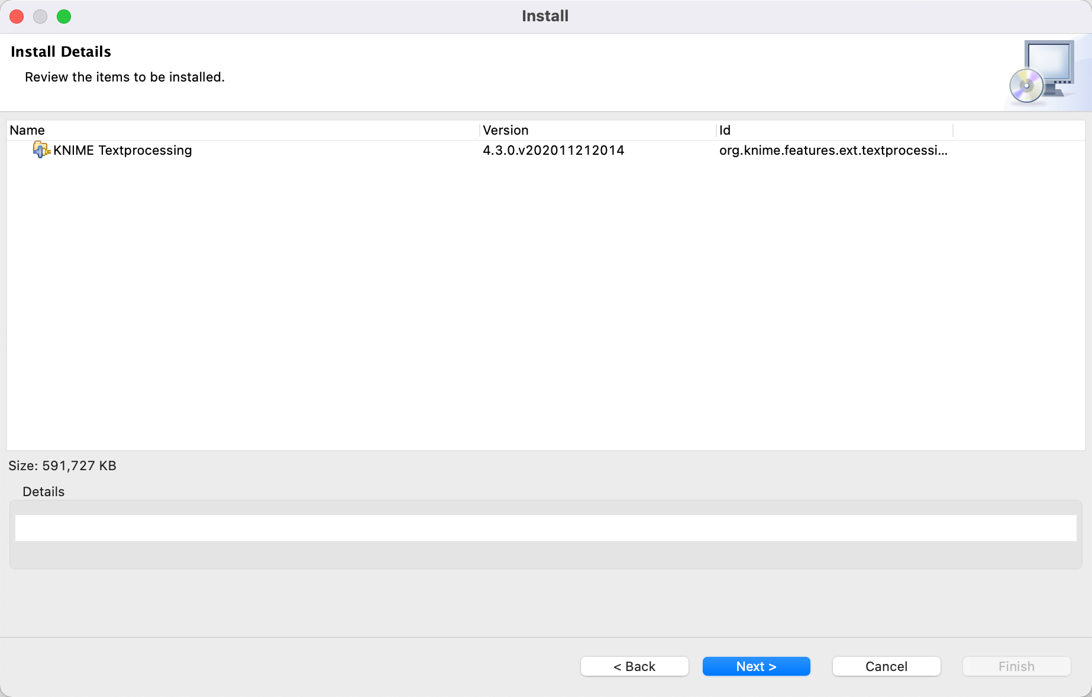

10 – I clicked Finish.

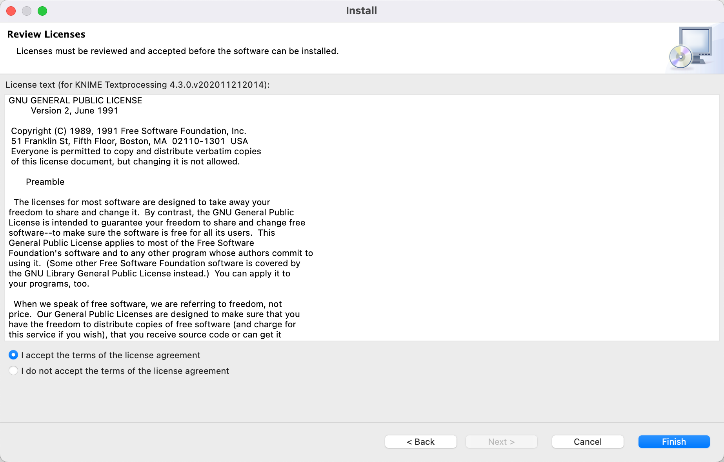

- And I clicked Restart Now button.

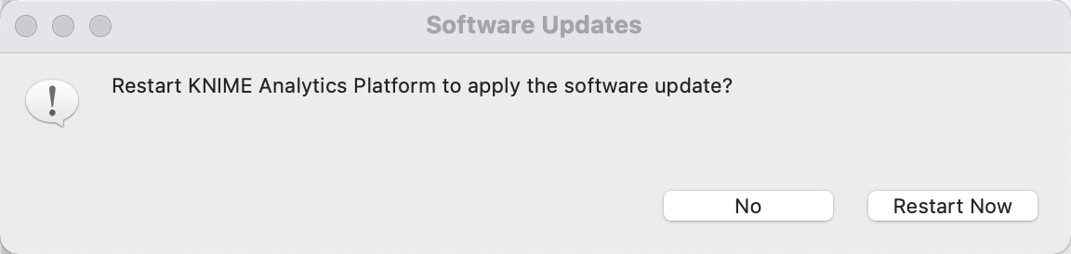

- The screen looks like this after restarting.

