Perfect Denis.
The only slight changes I applied to the Column Expressions node formula were as follows:
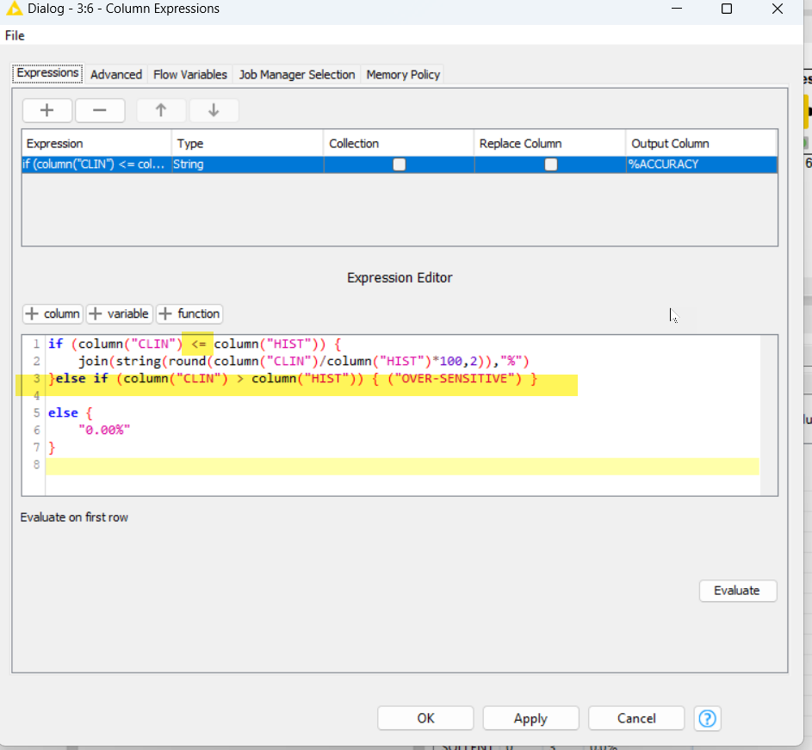
Which gives me the final output of:
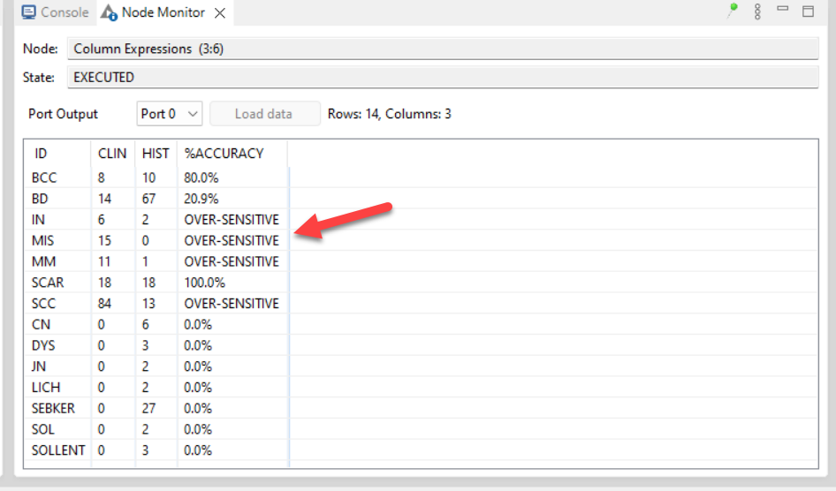
So for all technical purposes, Phase 1 of my project requirements are fulfilled.
The big challenge now is how can I also create a table matrix of all the various responses counts from the row data to look similar to the example from the other pathology provider?
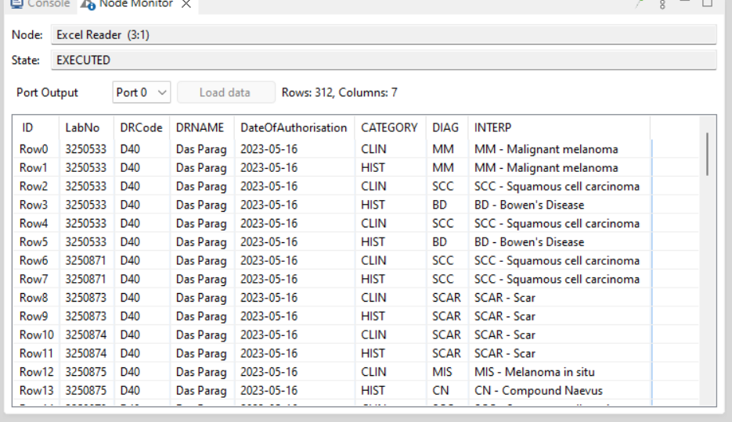
To something like this:
