I installed the Geospatial Analytics Extension for KNIME version 4.4.

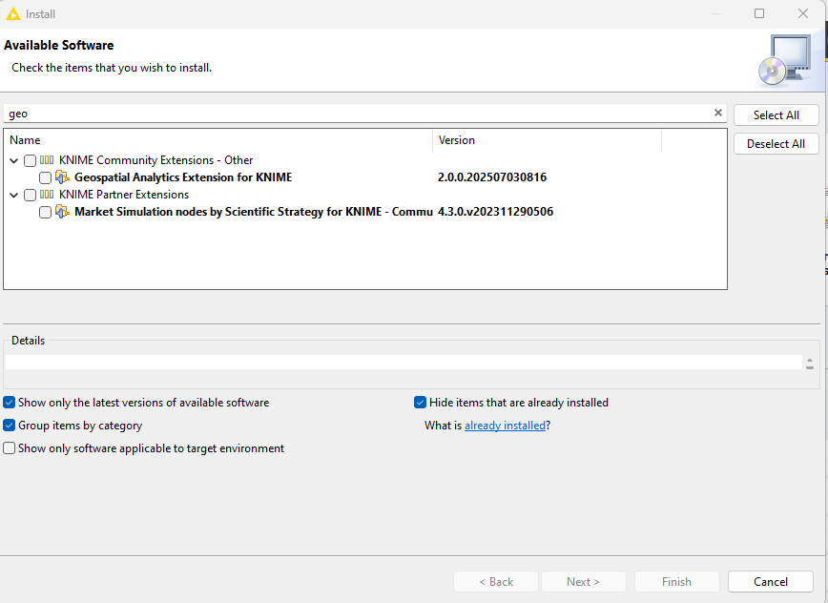I installed version 5.5 and ran the KNIME AP Migrator component in version 5.5.

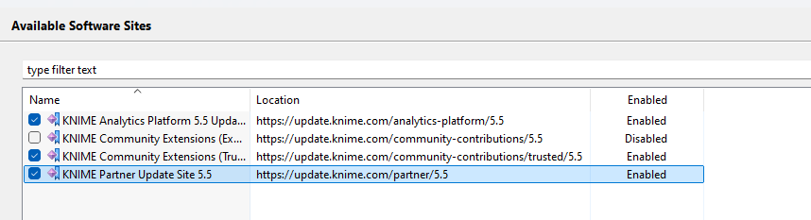

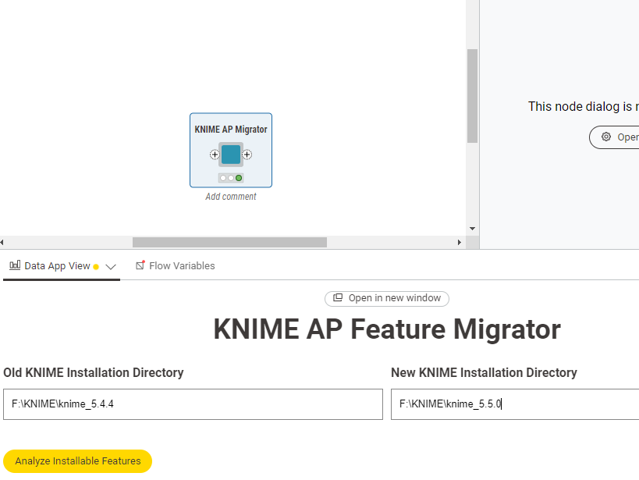

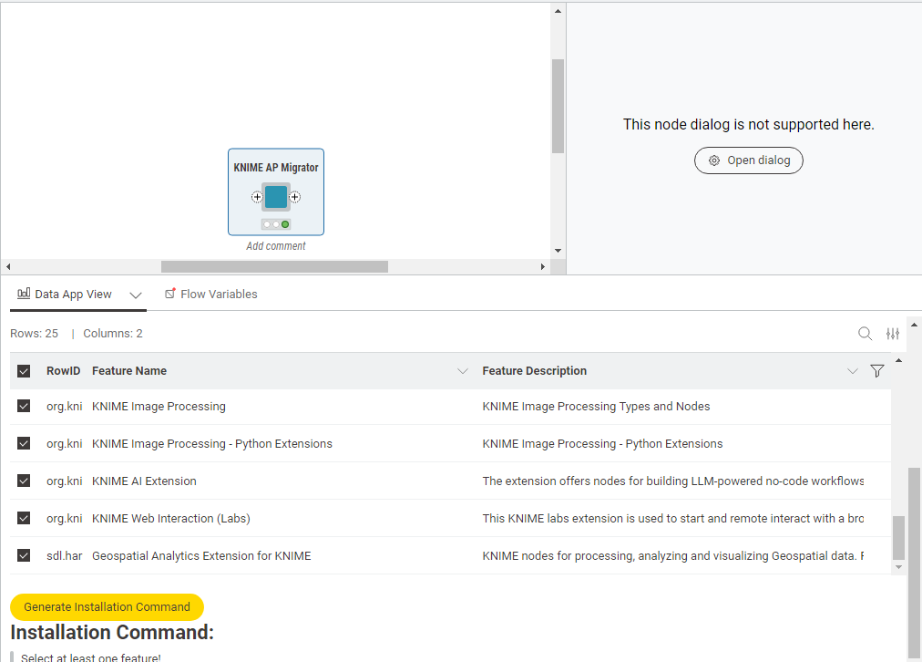

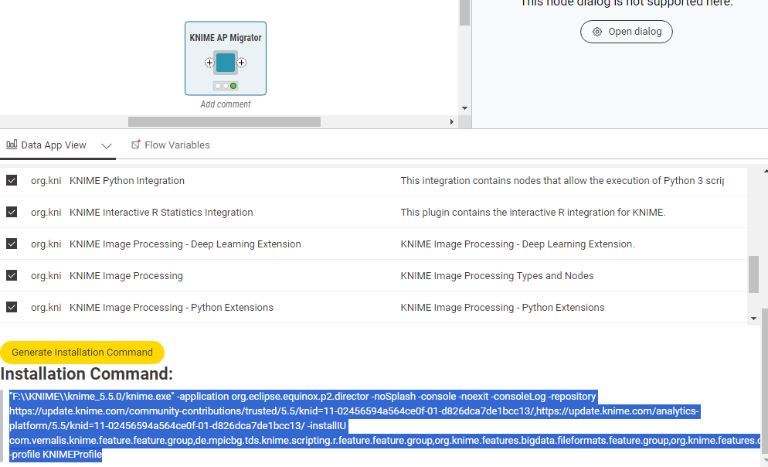

"F:\\KNIME\\knime_5.5.0/knime.exe" -application org.eclipse.equinox.p2.director -noSplash -console -noexit -consoleLog -repository https://update.knime.com/community-contributions/trusted/5.5/knid=11-02456594a564ce0f-01-d826dca7de1bcc13/,https://update.knime.com/analytics-platform/5.5/knid=11-02456594a564ce0f-01-d826dca7de1bcc13/ -installIU com.vernalis.knime.feature.feature.group,de.mpicbg.tds.knime.scripting.r.feature.feature.group,org.knime.features.bigdata.fileformats.feature.group,org.knime.features.cloud.aws.feature.group,org.knime.features.conda.feature.group,org.knime.features.datageneration.feature.group,org.knime.features.dl.keras.feature.group,org.knime.features.email.feature.group,org.knime.features.expressions.feature.group,org.knime.features.ext.exttool.feature.group,org.knime.features.ext.h2o.feature.group,org.knime.features.ext.h2o.mojo.feature.group,org.knime.features.ext.r.bin.feature.group,org.knime.features.ext.textprocessing.feature.group,org.knime.features.mli.feature.group,org.knime.features.python2.feature.group,org.knime.features.python3.nodes.feature.group,org.knime.features.python3.scripting.feature.group,org.knime.features.r.feature.group,org.knime.knip.dl.feature.feature.group,org.knime.knip.feature.feature.group,org.knime.knip.knimepython.feature.feature.group,org.knime.python.features.llm.feature.group,org.knime.python.features.web.feature.group,sdl.harvard.features.geospatial.feature.group -profile KNIMEProfile

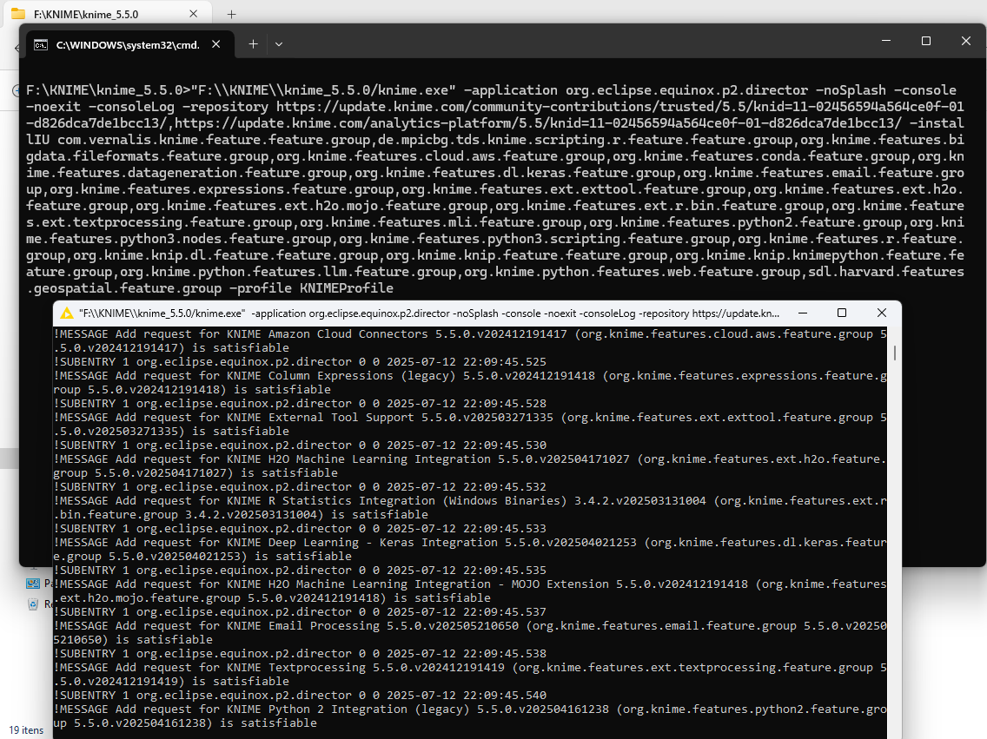

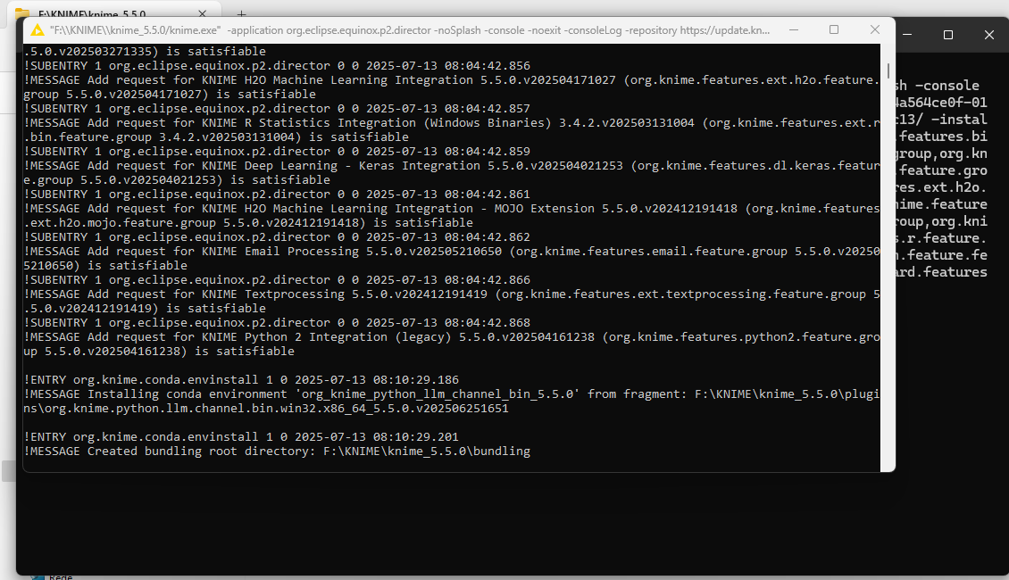

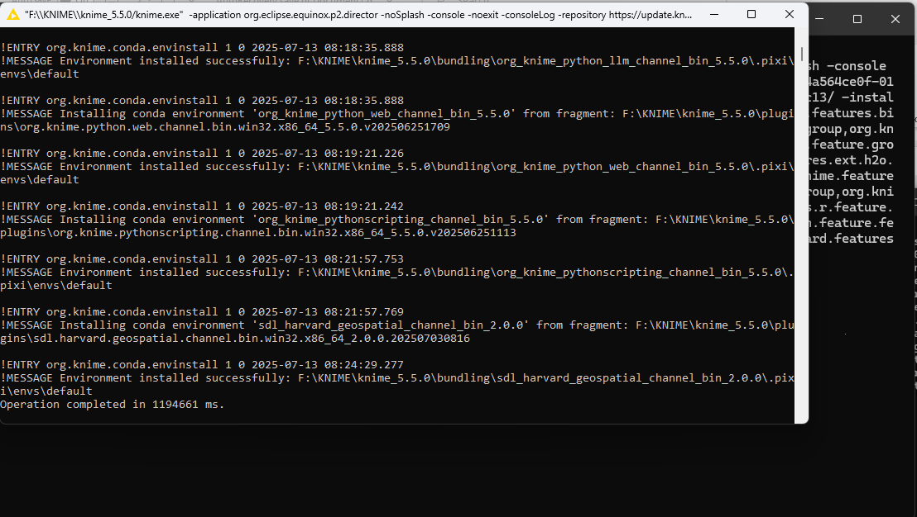

____________________________

Welcome to Apache Felix Gogo

g! Installing com.vernalis.knime.feature.feature.group 1.38.2.v202504171302.

Installing de.mpicbg.tds.knime.scripting.r.feature.feature.group 5.5.0.v202507010920.

Installing org.knime.features.bigdata.fileformats.feature.group 5.5.0.v202506201446.

Installing org.knime.features.cloud.aws.feature.group 5.5.0.v202412191417.

Installing org.knime.features.conda.feature.group 5.5.0.v202504161238.

Installing org.knime.features.datageneration.feature.group 5.5.0.v202412191418.

Installing org.knime.features.dl.keras.feature.group 5.5.0.v202504021253.

Installing org.knime.features.email.feature.group 5.5.0.v202505210650.

Installing org.knime.features.expressions.feature.group 5.5.0.v202412191418.

Installing org.knime.features.ext.exttool.feature.group 5.5.0.v202503271335.

Installing org.knime.features.ext.h2o.feature.group 5.5.0.v202504171027.

Installing org.knime.features.ext.h2o.mojo.feature.group 5.5.0.v202412191418.

Installing org.knime.features.ext.r.bin.feature.group 3.4.2.v202503131004.

Installing org.knime.features.ext.textprocessing.feature.group 5.5.0.v202412191419.

Installing org.knime.features.mli.feature.group 5.5.0.v202412191418.

Installing org.knime.features.python2.feature.group 5.5.0.v202504161238.

Installing org.knime.features.python3.nodes.feature.group 5.5.0.v202506241445.

Installing org.knime.features.python3.scripting.feature.group 5.5.0.v202506241404.

Installing org.knime.features.r.feature.group 5.5.0.v202412191418.

Installing org.knime.knip.dl.feature.feature.group 1.0.2.v202307191443.

Installing org.knime.knip.feature.feature.group 1.8.3.v202411281608.

Installing org.knime.knip.knimepython.feature.feature.group 1.0.10.v202307191444.

Installing org.knime.python.features.llm.feature.group 5.5.0.v202506251651.

Installing org.knime.python.features.web.feature.group 5.5.0.v202506251709.

Installing sdl.harvard.features.geospatial.feature.group 2.0.0.202507030816.

!SESSION 2025-07-13 08:03:41.778 -----------------------------------------------

eclipse.buildId=unknown

java.version=17.0.5

java.vendor=Eclipse Adoptium

BootLoader constants: OS=win32, ARCH=x86_64, WS=win32, NL=pt_PT

Framework arguments: -application org.eclipse.equinox.p2.director -repository https://update.knime.com/community-contributions/trusted/5.5/knid=11-02456594a564ce0f-01-d826dca7de1bcc13/,https://update.knime.com/analytics-platform/5.5/knid=11-02456594a564ce0f-01-d826dca7de1bcc13/ -installIU com.vernalis.knime.feature.feature.group,de.mpicbg.tds.knime.scripting.r.feature.feature.group,org.knime.features.bigdata.fileformats.feature.group,org.knime.features.cloud.aws.feature.group,org.knime.features.conda.feature.group,org.knime.features.datageneration.feature.group,org.knime.features.dl.keras.feature.group,org.knime.features.email.feature.group,org.knime.features.expressions.feature.group,org.knime.features.ext.exttool.feature.group,org.knime.features.ext.h2o.feature.group,org.knime.features.ext.h2o.mojo.feature.group,org.knime.features.ext.r.bin.feature.group,org.knime.features.ext.textprocessing.feature.group,org.knime.features.mli.feature.group,org.knime.features.python2.feature.group,org.knime.features.python3.nodes.feature.group,org.knime.features.python3.scripting.feature.group,org.knime.features.r.feature.group,org.knime.knip.dl.feature.feature.group,org.knime.knip.feature.feature.group,org.knime.knip.knimepython.feature.feature.group,org.knime.python.features.llm.feature.group,org.knime.python.features.web.feature.group,sdl.harvard.features.geospatial.feature.group -profile KNIMEProfile

Command-line arguments: -os win32 -ws win32 -arch x86_64 -application org.eclipse.equinox.p2.director -console -consoleLog -repository https://update.knime.com/community-contributions/trusted/5.5/knid=11-02456594a564ce0f-01-d826dca7de1bcc13/,https://update.knime.com/analytics-platform/5.5/knid=11-02456594a564ce0f-01-d826dca7de1bcc13/ -installIU com.vernalis.knime.feature.feature.group,de.mpicbg.tds.knime.scripting.r.feature.feature.group,org.knime.features.bigdata.fileformats.feature.group,org.knime.features.cloud.aws.feature.group,org.knime.features.conda.feature.group,org.knime.features.datageneration.feature.group,org.knime.features.dl.keras.feature.group,org.knime.features.email.feature.group,org.knime.features.expressions.feature.group,org.knime.features.ext.exttool.feature.group,org.knime.features.ext.h2o.feature.group,org.knime.features.ext.h2o.mojo.feature.group,org.knime.features.ext.r.bin.feature.group,org.knime.features.ext.textprocessing.feature.group,org.knime.features.mli.feature.group,org.knime.features.python2.feature.group,org.knime.features.python3.nodes.feature.group,org.knime.features.python3.scripting.feature.group,org.knime.features.r.feature.group,org.knime.knip.dl.feature.feature.group,org.knime.knip.feature.feature.group,org.knime.knip.knimepython.feature.feature.group,org.knime.python.features.llm.feature.group,org.knime.python.features.web.feature.group,sdl.harvard.features.geospatial.feature.group -profile KNIMEProfile

!ENTRY org.eclipse.equinox.p2.director 0 0 2025-07-13 08:04:42.819

!MESSAGE Overall install request is satisfiable

!SUBENTRY 1 org.eclipse.equinox.p2.director 0 0 2025-07-13 08:04:42.820

!MESSAGE Add request for KNIME Data Generation 5.5.0.v202412191418 (org.knime.features.datageneration.feature.group 5.5.0.v202412191418) is satisfiable

!SUBENTRY 1 org.eclipse.equinox.p2.director 0 0 2025-07-13 08:04:42.822

!MESSAGE Add request for KNIME R Scripting extension 5.5.0.v202507010920 (de.mpicbg.tds.knime.scripting.r.feature.feature.group 5.5.0.v202507010920) is satisfiable

!SUBENTRY 1 org.eclipse.equinox.p2.director 0 0 2025-07-13 08:04:42.824

!MESSAGE Add request for KNIME Extension for Big Data File Formats 5.5.0.v202506201446 (org.knime.features.bigdata.fileformats.feature.group 5.5.0.v202506201446) is satisfiable

!SUBENTRY 1 org.eclipse.equinox.p2.director 0 0 2025-07-13 08:04:42.826

!MESSAGE Add request for KNIME Image Processing - Python Extensions 1.0.10.v202307191444 (org.knime.knip.knimepython.feature.feature.group 1.0.10.v202307191444) is satisfiable

!SUBENTRY 1 org.eclipse.equinox.p2.director 0 0 2025-07-13 08:04:42.827

!MESSAGE Add request for KNIME Image Processing 1.8.3.v202411281608 (org.knime.knip.feature.feature.group 1.8.3.v202411281608) is satisfiable

!SUBENTRY 1 org.eclipse.equinox.p2.director 0 0 2025-07-13 08:04:42.829

!MESSAGE Add request for KNIME Machine Learning Interpretability Extension 5.5.0.v202412191418 (org.knime.features.mli.feature.group 5.5.0.v202412191418) is satisfiable

!SUBENTRY 1 org.eclipse.equinox.p2.director 0 0 2025-07-13 08:04:42.833

!MESSAGE Add request for Vernalis KNIME Nodes 1.38.2.v202504171302 (com.vernalis.knime.feature.feature.group 1.38.2.v202504171302) is satisfiable

!SUBENTRY 1 org.eclipse.equinox.p2.director 0 0 2025-07-13 08:04:42.835

!MESSAGE Add request for KNIME Python Integration 5.5.0.v202506241404 (org.knime.features.python3.scripting.feature.group 5.5.0.v202506241404) is satisfiable

!SUBENTRY 1 org.eclipse.equinox.p2.director 0 0 2025-07-13 08:04:42.837

!MESSAGE Add request for KNIME AI Extension 5.5.0.v202506251651 (org.knime.python.features.llm.feature.group 5.5.0.v202506251651) is satisfiable

!SUBENTRY 1 org.eclipse.equinox.p2.director 0 0 2025-07-13 08:04:42.839

!MESSAGE Add request for KNIME Python Extension Development (Labs) 5.5.0.v202506241445 (org.knime.features.python3.nodes.feature.group 5.5.0.v202506241445) is satisfiable

!SUBENTRY 1 org.eclipse.equinox.p2.director 0 0 2025-07-13 08:04:42.841

!MESSAGE Add request for KNIME Conda Integration 5.5.0.v202504161238 (org.knime.features.conda.feature.group 5.5.0.v202504161238) is satisfiable

!SUBENTRY 1 org.eclipse.equinox.p2.director 0 0 2025-07-13 08:04:42.842

!MESSAGE Add request for KNIME Interactive R Statistics Integration 5.5.0.v202412191418 (org.knime.features.r.feature.group 5.5.0.v202412191418) is satisfiable

!SUBENTRY 1 org.eclipse.equinox.p2.director 0 0 2025-07-13 08:04:42.844

!MESSAGE Add request for KNIME Web Interaction (Labs) 5.5.0.v202506251709 (org.knime.python.features.web.feature.group 5.5.0.v202506251709) is satisfiable

!SUBENTRY 1 org.eclipse.equinox.p2.director 0 0 2025-07-13 08:04:42.845

!MESSAGE Add request for Geospatial Analytics Extension for KNIME 2.0.0.202507030816 (sdl.harvard.features.geospatial.feature.group 2.0.0.202507030816) is satisfiable

!SUBENTRY 1 org.eclipse.equinox.p2.director 0 0 2025-07-13 08:04:42.849

!MESSAGE Add request for KNIME Image Processing - Deep Learning Extension 1.0.2.v202307191443 (org.knime.knip.dl.feature.feature.group 1.0.2.v202307191443) is satisfiable

!SUBENTRY 1 org.eclipse.equinox.p2.director 0 0 2025-07-13 08:04:42.850

!MESSAGE Add request for KNIME Amazon Cloud Connectors 5.5.0.v202412191417 (org.knime.features.cloud.aws.feature.group 5.5.0.v202412191417) is satisfiable

!SUBENTRY 1 org.eclipse.equinox.p2.director 0 0 2025-07-13 08:04:42.852

!MESSAGE Add request for KNIME Column Expressions (legacy) 5.5.0.v202412191418 (org.knime.features.expressions.feature.group 5.5.0.v202412191418) is satisfiable

!SUBENTRY 1 org.eclipse.equinox.p2.director 0 0 2025-07-13 08:04:42.854

!MESSAGE Add request for KNIME External Tool Support 5.5.0.v202503271335 (org.knime.features.ext.exttool.feature.group 5.5.0.v202503271335) is satisfiable

!SUBENTRY 1 org.eclipse.equinox.p2.director 0 0 2025-07-13 08:04:42.856

!MESSAGE Add request for KNIME H2O Machine Learning Integration 5.5.0.v202504171027 (org.knime.features.ext.h2o.feature.group 5.5.0.v202504171027) is satisfiable

!SUBENTRY 1 org.eclipse.equinox.p2.director 0 0 2025-07-13 08:04:42.857

!MESSAGE Add request for KNIME R Statistics Integration (Windows Binaries) 3.4.2.v202503131004 (org.knime.features.ext.r.bin.feature.group 3.4.2.v202503131004) is satisfiable

!SUBENTRY 1 org.eclipse.equinox.p2.director 0 0 2025-07-13 08:04:42.859

!MESSAGE Add request for KNIME Deep Learning - Keras Integration 5.5.0.v202504021253 (org.knime.features.dl.keras.feature.group 5.5.0.v202504021253) is satisfiable

!SUBENTRY 1 org.eclipse.equinox.p2.director 0 0 2025-07-13 08:04:42.861

!MESSAGE Add request for KNIME H2O Machine Learning Integration - MOJO Extension 5.5.0.v202412191418 (org.knime.features.ext.h2o.mojo.feature.group 5.5.0.v202412191418) is satisfiable

!SUBENTRY 1 org.eclipse.equinox.p2.director 0 0 2025-07-13 08:04:42.862

!MESSAGE Add request for KNIME Email Processing 5.5.0.v202505210650 (org.knime.features.email.feature.group 5.5.0.v202505210650) is satisfiable

!SUBENTRY 1 org.eclipse.equinox.p2.director 0 0 2025-07-13 08:04:42.866

!MESSAGE Add request for KNIME Textprocessing 5.5.0.v202412191419 (org.knime.features.ext.textprocessing.feature.group 5.5.0.v202412191419) is satisfiable

!SUBENTRY 1 org.eclipse.equinox.p2.director 0 0 2025-07-13 08:04:42.868

!MESSAGE Add request for KNIME Python 2 Integration (legacy) 5.5.0.v202504161238 (org.knime.features.python2.feature.group 5.5.0.v202504161238) is satisfiable

!ENTRY org.knime.conda.envinstall 1 0 2025-07-13 08:10:29.186

!MESSAGE Installing conda environment 'org_knime_python_llm_channel_bin_5.5.0' from fragment: F:\KNIME\knime_5.5.0\plugins\org.knime.python.llm.channel.bin.win32.x86_64_5.5.0.v202506251651

!ENTRY org.knime.conda.envinstall 1 0 2025-07-13 08:10:29.201

!MESSAGE Created bundling root directory: F:\KNIME\knime_5.5.0\bundling

!ENTRY org.knime.conda.envinstall 1 0 2025-07-13 08:18:35.888

!MESSAGE Environment installed successfully: F:\KNIME\knime_5.5.0\bundling\org_knime_python_llm_channel_bin_5.5.0\.pixi\envs\default

!ENTRY org.knime.conda.envinstall 1 0 2025-07-13 08:18:35.888

!MESSAGE Installing conda environment 'org_knime_python_web_channel_bin_5.5.0' from fragment: F:\KNIME\knime_5.5.0\plugins\org.knime.python.web.channel.bin.win32.x86_64_5.5.0.v202506251709

!ENTRY org.knime.conda.envinstall 1 0 2025-07-13 08:19:21.226

!MESSAGE Environment installed successfully: F:\KNIME\knime_5.5.0\bundling\org_knime_python_web_channel_bin_5.5.0\.pixi\envs\default

!ENTRY org.knime.conda.envinstall 1 0 2025-07-13 08:19:21.242

!MESSAGE Installing conda environment 'org_knime_pythonscripting_channel_bin_5.5.0' from fragment: F:\KNIME\knime_5.5.0\plugins\org.knime.pythonscripting.channel.bin.win32.x86_64_5.5.0.v202506251113

!ENTRY org.knime.conda.envinstall 1 0 2025-07-13 08:21:57.753

!MESSAGE Environment installed successfully: F:\KNIME\knime_5.5.0\bundling\org_knime_pythonscripting_channel_bin_5.5.0\.pixi\envs\default

!ENTRY org.knime.conda.envinstall 1 0 2025-07-13 08:21:57.769

!MESSAGE Installing conda environment 'sdl_harvard_geospatial_channel_bin_2.0.0' from fragment: F:\KNIME\knime_5.5.0\plugins\sdl.harvard.geospatial.channel.bin.win32.x86_64_2.0.0.202507030816

!ENTRY org.knime.conda.envinstall 1 0 2025-07-13 08:24:29.277

!MESSAGE Environment installed successfully: F:\KNIME\knime_5.5.0\bundling\sdl_harvard_geospatial_channel_bin_2.0.0\.pixi\envs\default

Operation completed in 1194661 ms.

I verify and the extension

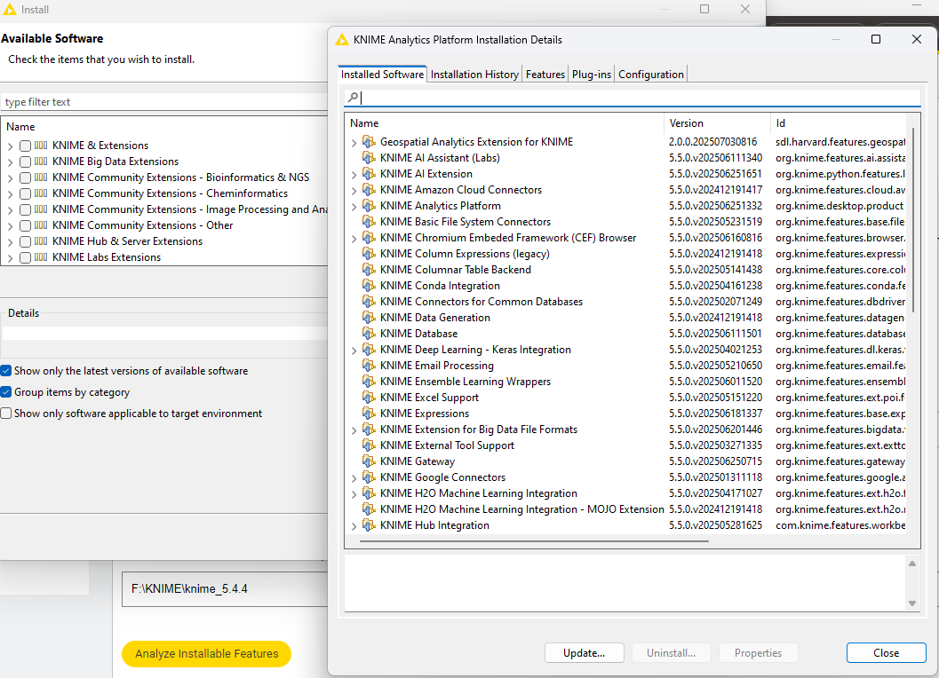

And nodes were available.

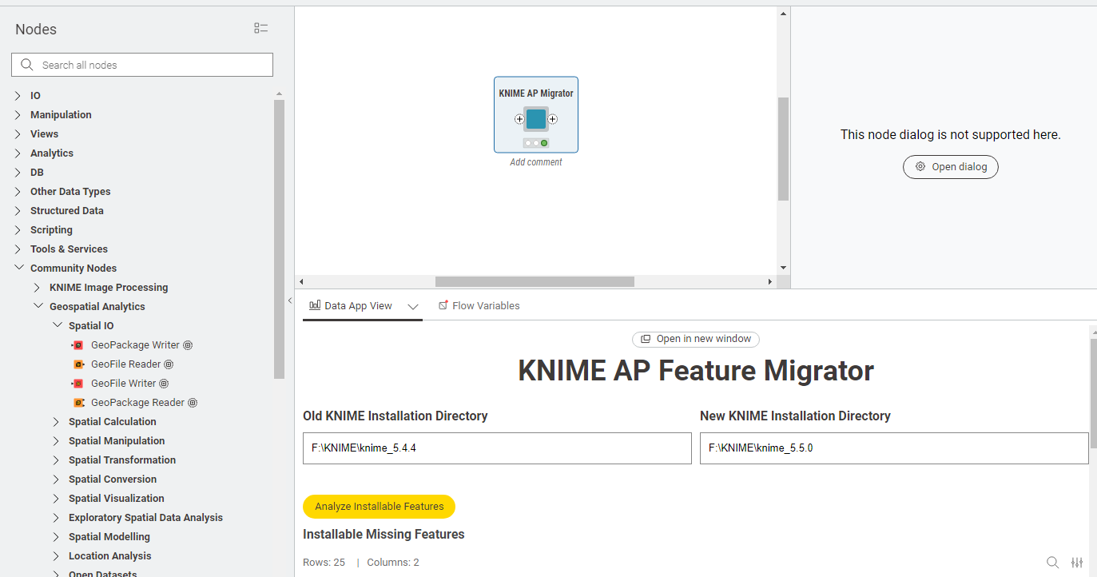

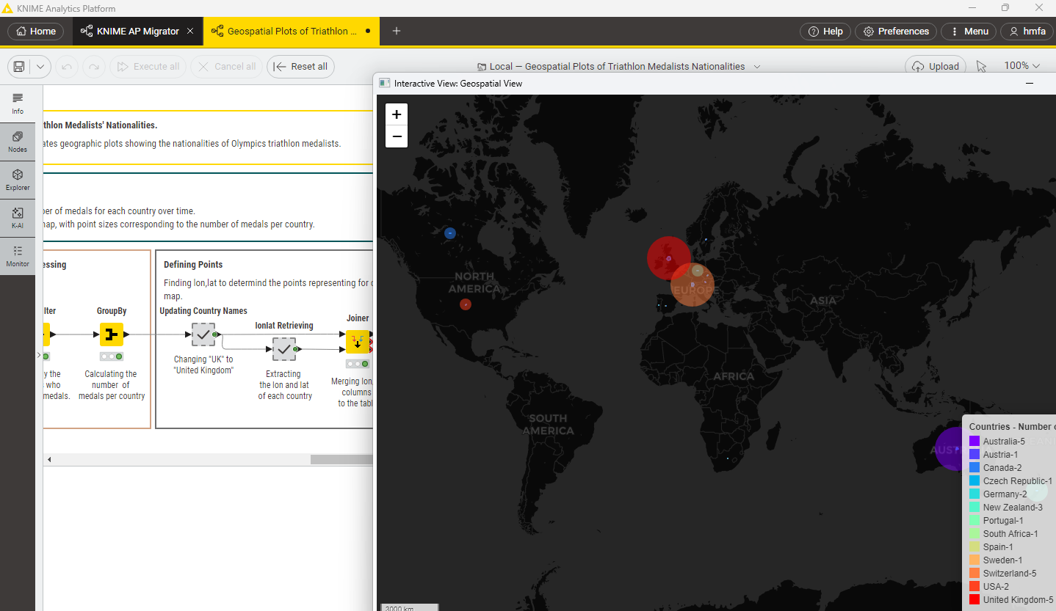

It worked for me.

Thanks a lot.